**NAME:PAREENITA A.SHIRSATH PRN:221101062 T.E.A.I.&.D.S. ROLL.NO:57**

**SEPM EXPERIMENT 2**

**1. Download GitHub Desktop:**

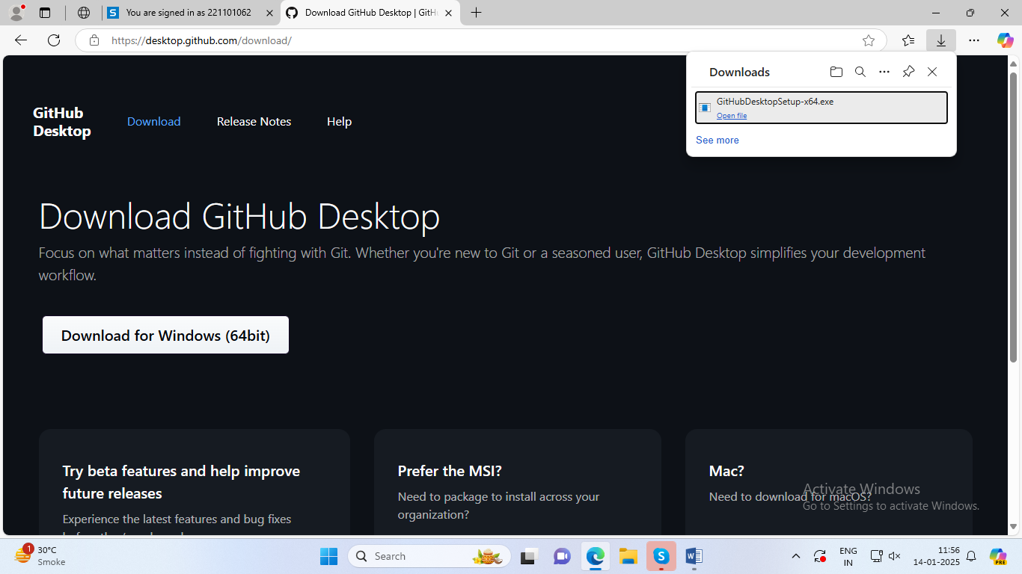

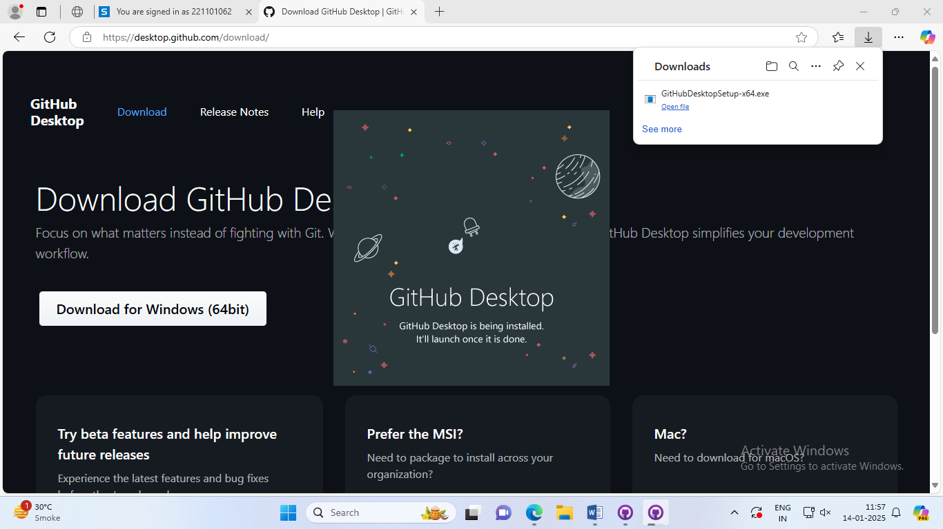

**2.Opening window of Git :**

]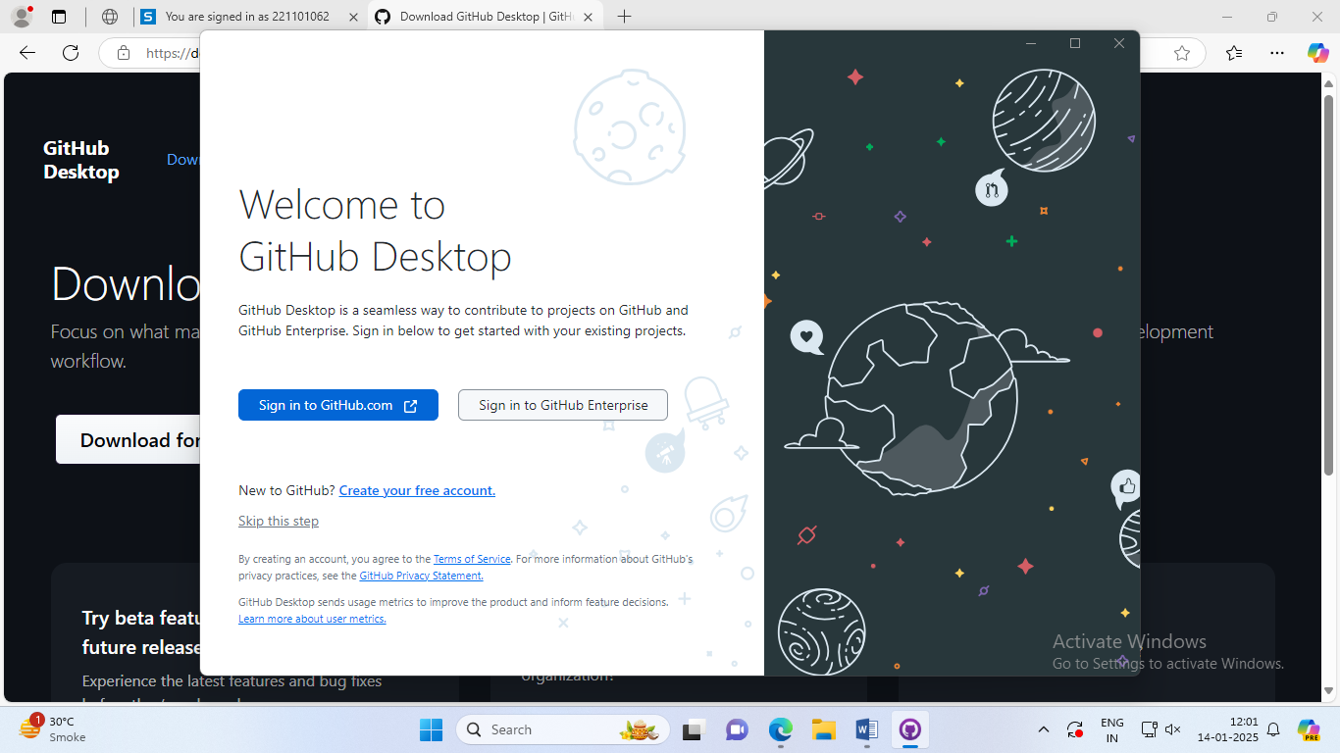

**3.Creating Account:**

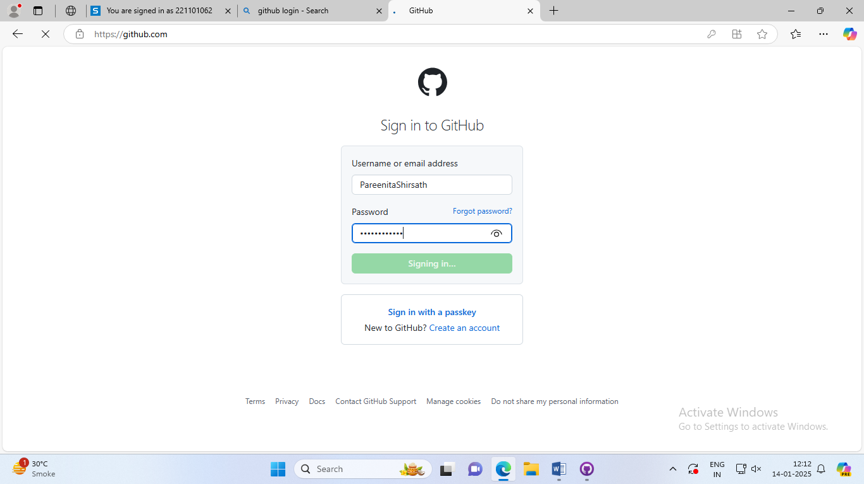

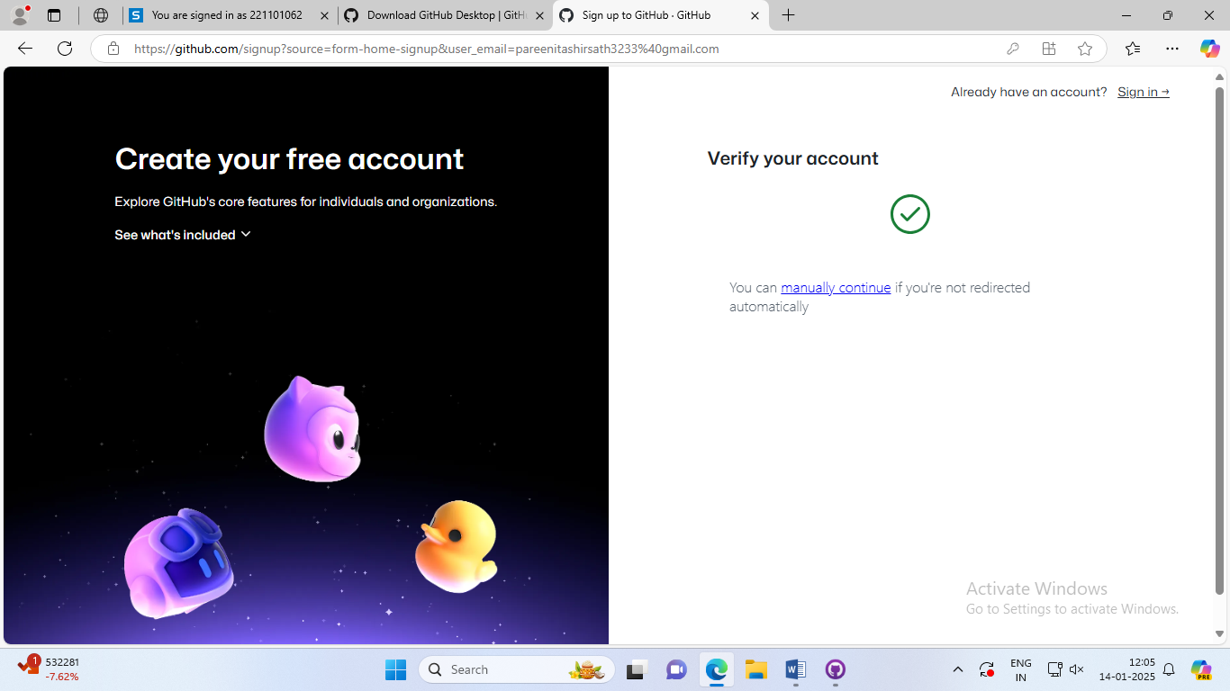

**4.Created Account Overview:**

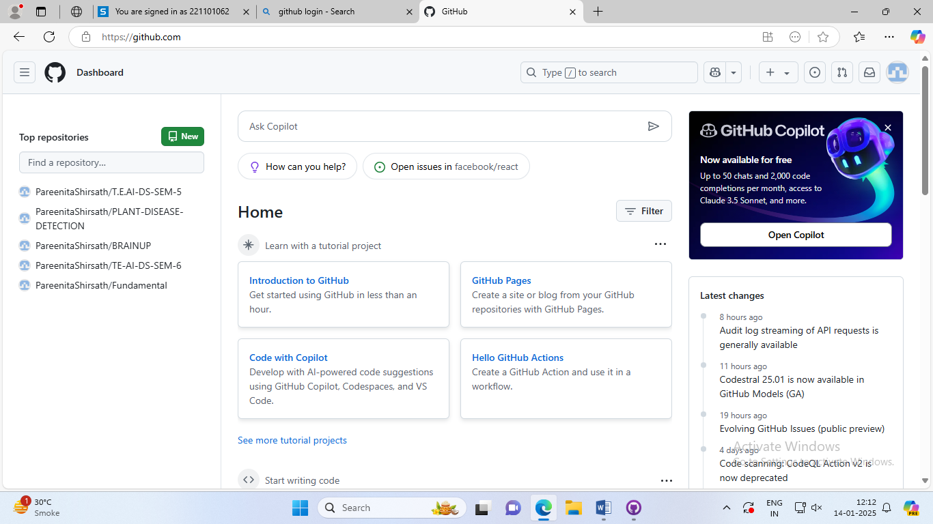

**What is Git?**

* **Definition**: Git is a distributed version control system (VCS) used to track changes in source code during software development.
* **Purpose**: It helps developers manage changes to code over time, collaborate with others, and maintain a history of code versions.
* **How It Works**: Git allows developers to create a local repository (a versioned copy of the project) on their computer. With Git, developers can:
  + Commit changes to their local repository.
  + Branch off to create new features or experiments.
  + Merge changes back into the main branch (e.g., main or master).
  + Push and pull changes from a remote repository (e.g., GitHub).

**What is GitHub?**

* **Definition**: GitHub is a cloud-based platform that hosts Git repositories and provides collaboration tools. It allows developers to store and share their code online.
* **Purpose**: GitHub is a Git hosting service that enables teams and individuals to work together on projects by providing version control (via Git) along with additional features like:
  + Pull requests: a way to propose code changes.
  + Issue tracking: to manage tasks and bugs.
  + Wiki and documentation support.
  + Continuous Integration (CI) and Deployment (CD) support.
  + Collaboration tools like discussions and team management.

**How Git and GitHub Work Together?**

* **Git** is used for version control on your local machine, while **GitHub** provides a central repository in the cloud to share code and collaborate with others.
* Developers use Git on their local machine to commit changes, and then use GitHub to push their commits to the remote repository, share code, and collaborate.
* Developers can clone a GitHub repository to their local machine, make changes using Git, and then push those changes back to GitHub.

**What are the Differences Between Them?**

|  |  |  |
| --- | --- | --- |
| **ASPECT** | **GIT** | **GITHUB** |
| **Type** | Version control system. | |  | | --- | | Cloud-based hosting platform for Git repositories. |  |  | | --- | |  | |
| **Usage** | Track code changes locally. | Store and share Git repositories remotely. |
| **Functionality** | Manages versions and branches of code. | Hosts remote repositories, facilitates collaboration, and integrates with other services. |
| **Installation** | Installed locally on your computer. | Web-based platform with no installation needed. |